Data Sources:
Following are Spark’s core data sources:
- CSV
- JSON
- Parquet
- ORC
- JDBC/ODBC connections
- Plain-text files

Spark has numerous community-created data sources.
- Cassandra, MongoDB, HBase, RedShift and many more

Basics of Reading Data:
- The core structure for reading data is as follows:
DataFrameReader.format(...).option("key", "value").schema(...).load()
We will use this format to read from all of our data sources.
- The foundation for reading data in Spark is the DataFrameReader. We access this through the SparkSession via the read attribute:
spark.read
Example:
Read modes:
- Reading data from an external source naturally entails encountering malformed data, especially when working with only semi-structured data sources.
- Read modes specify what will happen when Spark does come across malformed records.
Following are different read modes,
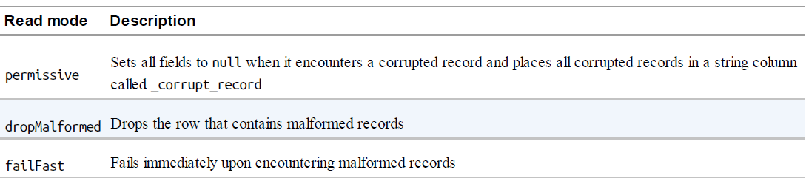

Default read mode is ‘permissive’

Basics of writing data:
- The core structure for writing data is as follows:
DataFrameWriter.format(...).option(...).partitionBy(...).bucketBy(...).sortBy(...).save()
- The foundation for writing data is DataFrameWriter.
- We access the DataFrameWriter on a per-DataFrame basis via the write attribute:
dataFrame.write
- After we have a DataFrameWriter, we specify three values: the format, a series of options, and the save mode.
Example:

Save modes:
- Save modes specify what will happen if Spark finds data at the specified location.
- Available save modes are,
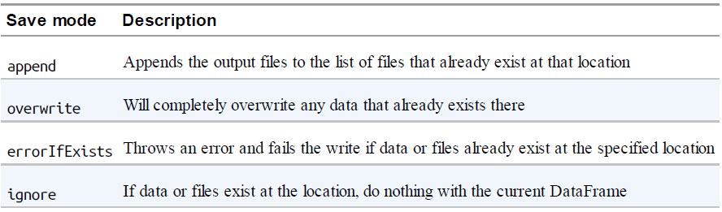
Default is errorIfExists.

CSV Files:
- CSV stands for comma-separated values. This is a common text file format in which each line represents a single record, and commas separate each field within a record.

CSV Options:
- CSV file format is the trickiest format, because not many assumptions can be made in production scenarios about what they contain or how they are structured. For this reason, the CSV reader has a large number of options.

For more options, refer official Spark documentation
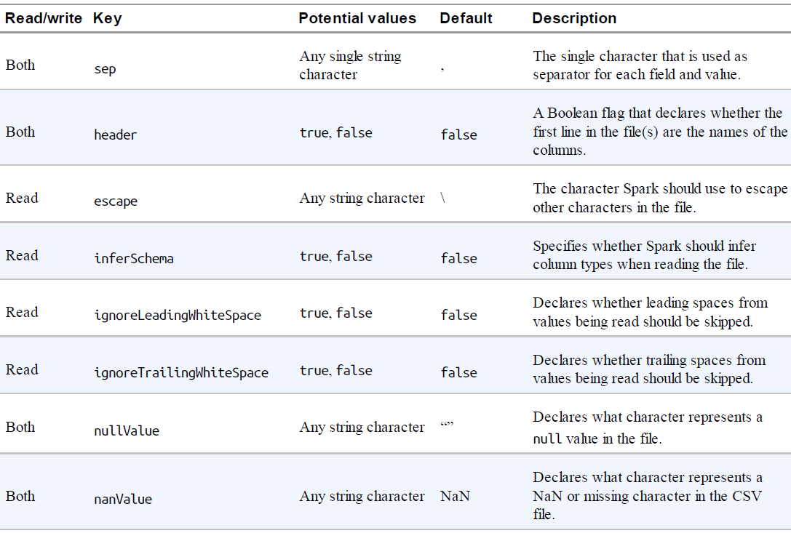
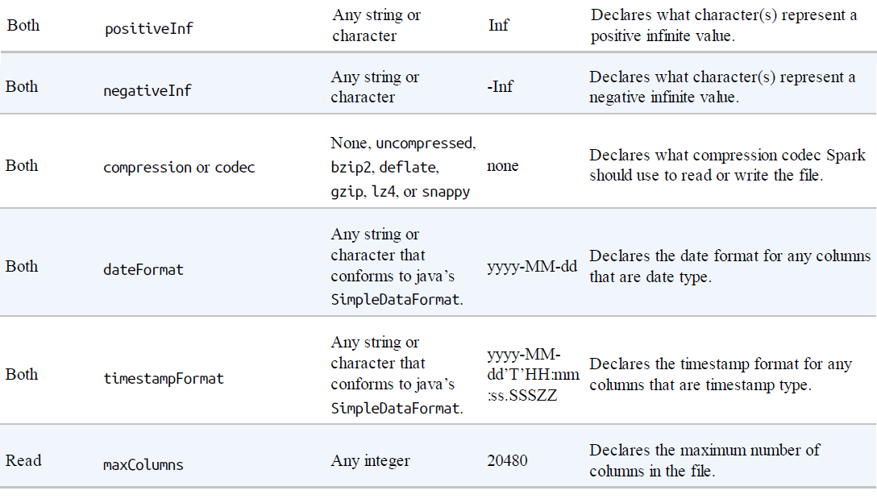
Reading CSV Files:
- To read a CSV file, like any other format, we must first create a DataFrameReader for that specific format.
spark.read.format("csv")
- After this, we have the option of specifying a schema as well as modes as options.

Example:

- Let’s take our current schema and change all column types to LongType. This does not match the actual schema, as soon as we start our Spark job, it will immediately fail

Example:

Writing CSV Files:
- Just as with reading data, there are a variety of options for writing data when we write CSV files.

For instance, we can take our CSV file and write it out as a TSV file quite easily:

JSON Files:
- Spark can process single line JSON file or a large JSON object presented in a single file. This can be controlled with ‘multiLine’ option.
JSON Options:
- Following are the few options (for more options, refer Spark documentation)

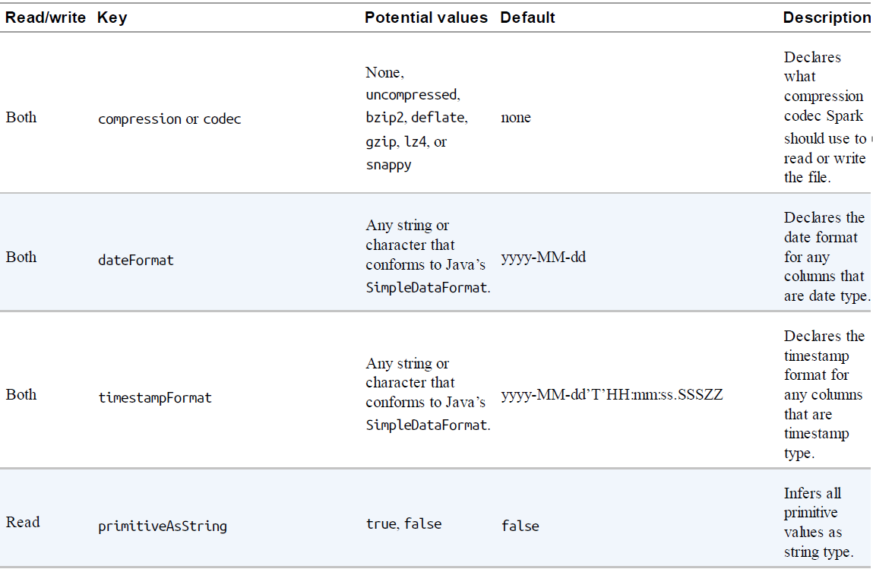
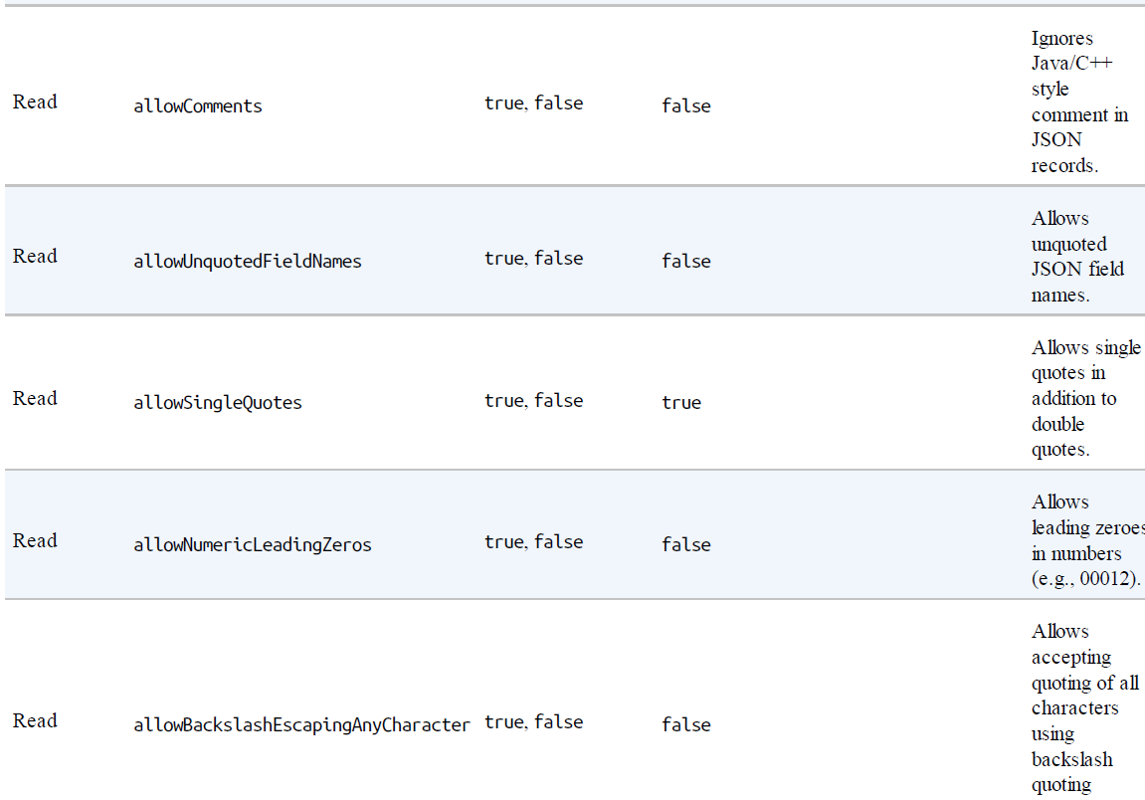
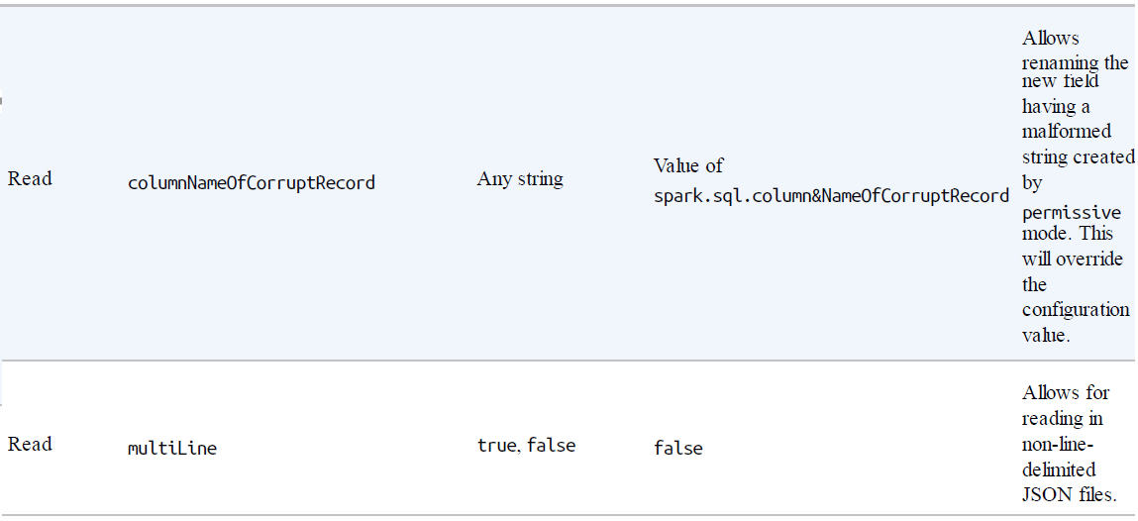

Reading JSON Files:
- Let’s look at an example of reading a JSON file and compare the options that we’re seeing:
Writing JSON Files:
- Following example writes the CSV DataFrame data to JSON file.

Parquet Files:
- Parquet is an open source column-oriented data store that provides a variety of storage optimizations, especially for analytics workloads.
- It is a file format that works exceptionally well with Apache Spark and is in fact the default file format.
- We recommend writing data out to Parquet for long-term storage because reading from a Parquet file will always be more efficient than JSON or CSV.
- Another advantage of Parquet is that it supports complex types.

Parquet options:
- Parquet has very few options because it enforces its own schema when storing data. Thus, all you need to set is the format and you are good to go.

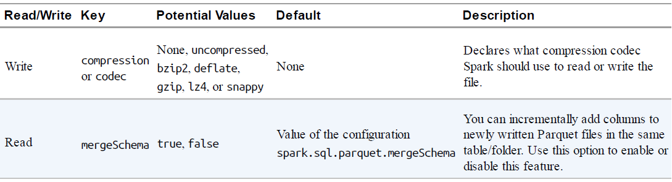

Reading Parquet Files:
- Creating a dataframe with Parquet data,

Writing Parquet Files:
- Writing Parquet is as easy as reading it. We simply specify the location for the file.
ORC Files:
- ORC is a self-describing, type-aware columnar file format designed for Hadoop workloads.
- Fundamental difference between Parquet and ORC is that Parquet is further optimized for use with Spark, whereas ORC is further optimized for Hive.

Reading ORC Files:
- Here’s how to read an ORC file into Spark:
Example:

Writing ORC Files:
Text Files:
- Spark also allows you to read in plain-text files. Each line in the file becomes a record in the DataFrame. It is then up to you to transform it accordingly.
- As an example of how you would do this,suppose that you need to parse some Apache log files to some more structured format, or perhaps you want to parse some plain text for natural-language processing.

Reading Text Files:
- Reading text files is straightforward: you simply specify the type to be textFile.
Example:

Writing Text Files:
- When you write a text file, you need to be sure to have only one string column; otherwise, the write will fail:

- If you perform some partitioning when performing your write, you can write more columns. However, those columns will manifest as directories in the folder to which you’re writing out to, instead of columns on every single file:

SQL Databases:
- SQL datasources are one of the more powerful connectors because there are a variety of systems to which you can connect.
- You can connect to different databases like PostgreSQL, Oracle, SQLite etc.
- To read and write from these databases, you need to do two things:
  - Include the Java Database Connectivity (JDBC) driver for you particular database on the spark classpath,
  - Provide the proper JAR for the driver itself.
Example:
pyspark \
--driver-class-path postgresql-9.4.1207.jar\
--jars postgresql-9.4.1207.jar

SQL DB data source options:
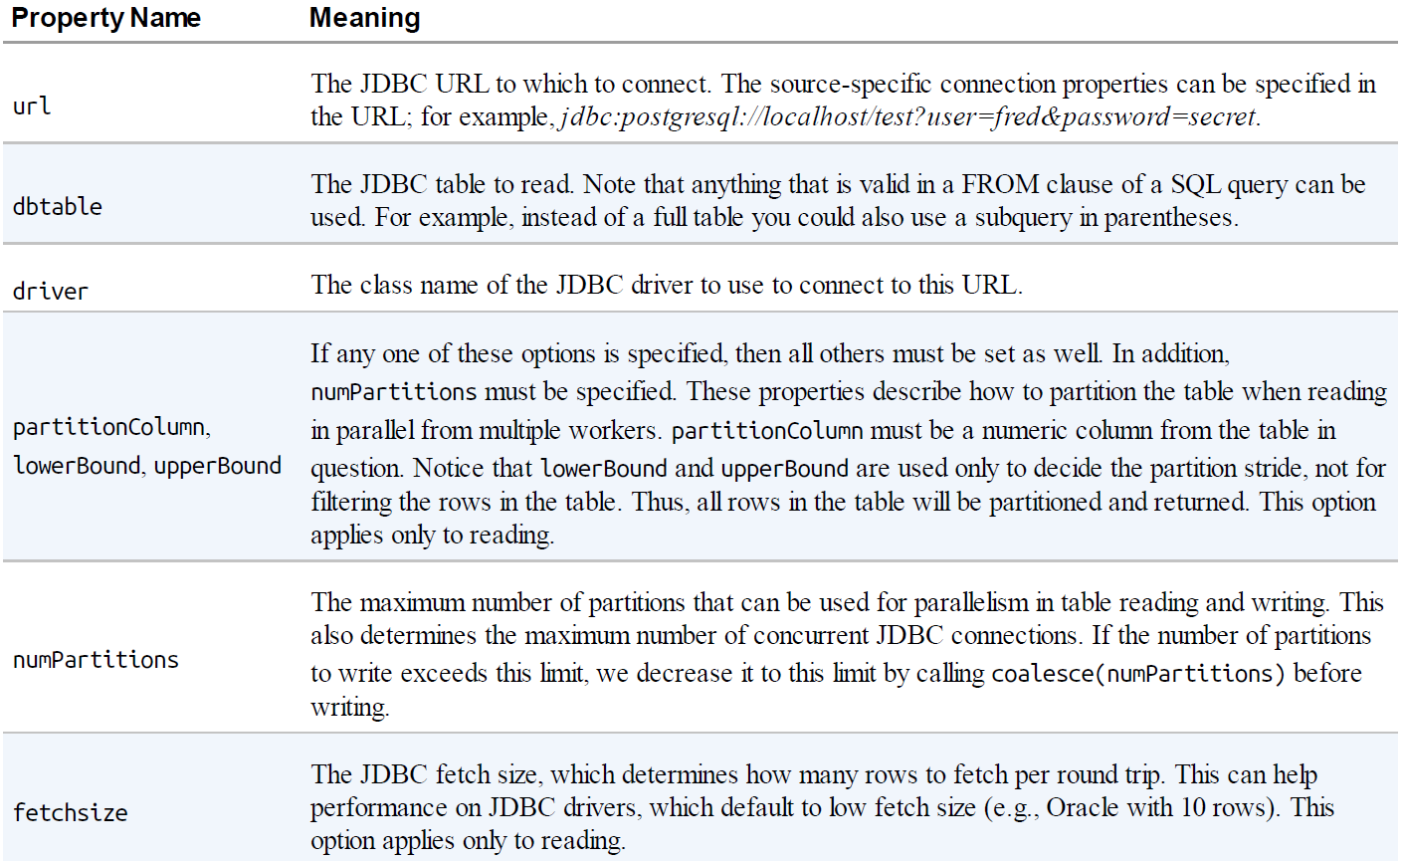
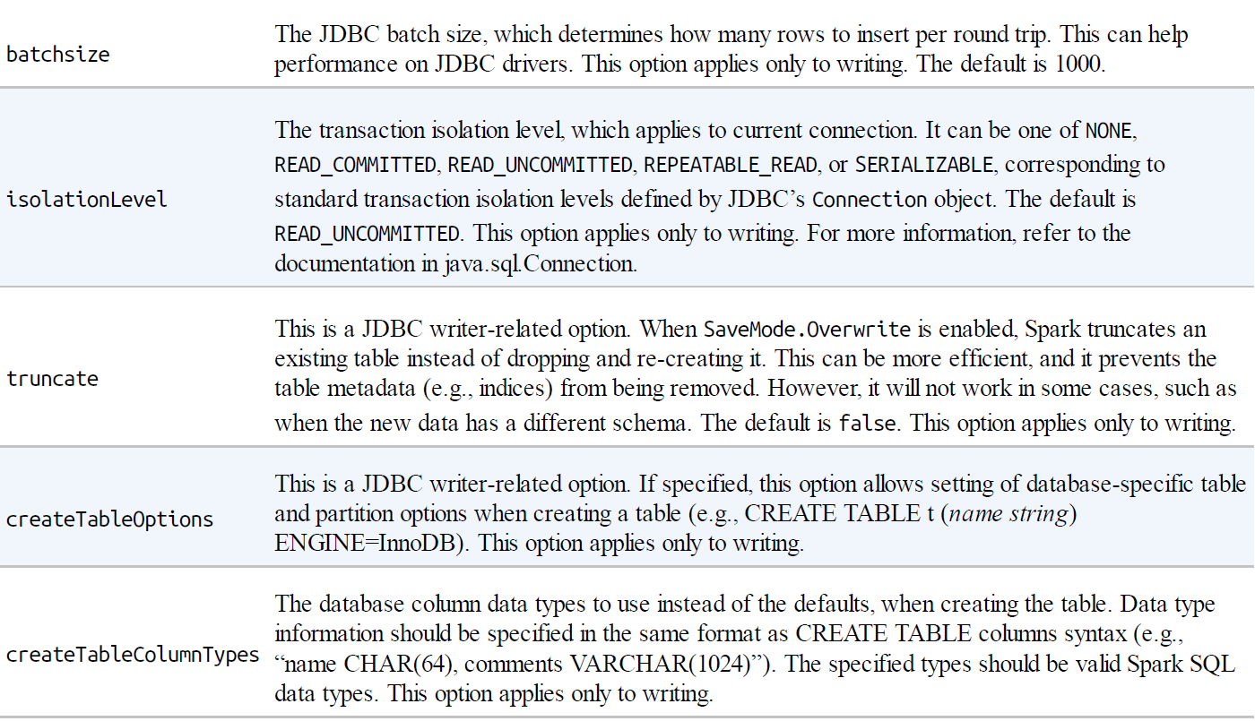

Reading from SQL Databases:
- To create data frame from DB table, need to make sure the connection between Spark and DB is fine. Connection check can be done like below:
Example:
import java.sql.DriverManager
val connection = DriverManager.getConnection(<JDBC URL>)
connection.isClosed()
connection.close()

- For interacting with DB, need to provide options like JDBC driver, JDBC URL, UserName, Password/Psswordf file, TableName etc.
Example:

Writing to SQL Databases:
- You simply specify the URI and write out the data according to the specified write mode that you want.
Example:

